Total Points: 25 points
Synthesis is about precisely defining the length of elements to accurately generate the correct motion. Print the assignment out at full size on a normal piece of paper, and use the graphical synthesis tools developed in class to find real lengths. For all of these problems, you will be graded not just on applying the right steps, but also on precision and accuracy.
Problem 1 (20 pts): Design a quick return 4 bar linkage whose input is driven by a constant speed motor and whose output oscillates between 42 degrees and 110 degrees with the clockwise motion time being 1.2 times slower than the counter-clockwise motion. The ground pivot points (O₂ and O₄) should not be further than 8 inches apart.
  - (5 pt) Calculate the angles needed to achieve this time ratio

  - (5 pts) Show the sketch of the graphical construction used to synthesize the quick return mechanism, with important angles indicated.

  - (4 pts) Draw the final four bar linkage to scale

  - (2 pts) List the lengths of all the links

  - (2 pts) What is the angle of the GND link measured counter clockwise with respect to the horizontal

  - (2 pts) Identify the class and inversion type of your mechanism

Problem 2 (10 pts): Three position synthesis
2.1 (6 pt) Using Graphical Linkage Synthesis, design a four-bar mechanism to give the three positions of the coupler motion shown below.

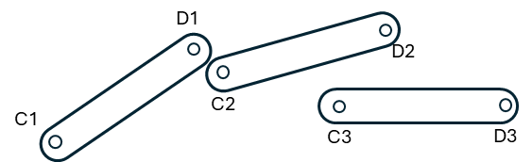

2.2 (4 pts) Does the mechanism have a toggle position at either of the prescribed positions? If so, how would you overcome this?

Select one of the following options:
- My answer was created by a Gen AI algorithm, and I have not modified it
- My answer was created by a Gen AI algorithm, and I have made some minor changes.
- My answer was created by a Gen AI algorithm, and I have made major changes.
- My answer was created solely by myself.
- If I used Gen AI, I used ___ (name of program).

